In order to logon to the web server (via SSH or sFTP), simply use your existing Ivy Tech login ID and password. Username is case sensitive and should be all lowercase.

Generic URL to access the server:

https://bobbi.ivytech.edu/[course]/[SECTION]
https://bobbi.ivytech.edu/~[username]

Windows Filezilla Access:

Download Filezilla https://filezilla-project.org/download.php?type=client

Run filezilla.
Enter host (bobbi.ivytech.edu), username (Ivy Tech login ID), password, and port number (22).
Click Quickconnect button.

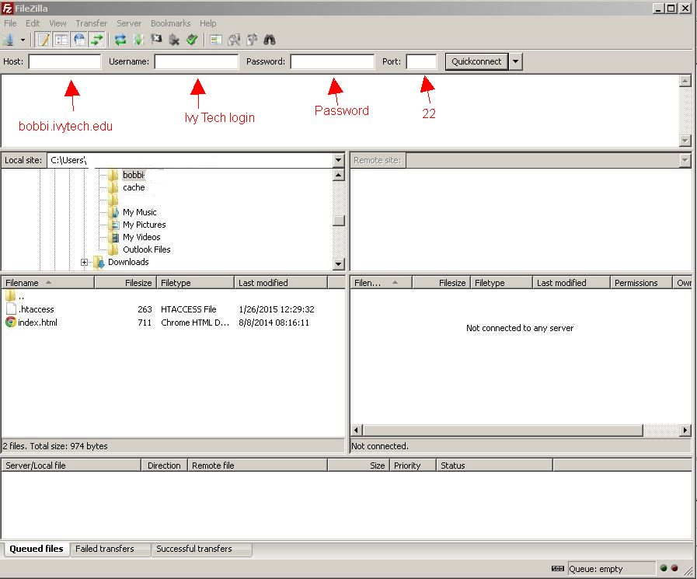

Drag class files to the public_html folder on bobbi.ivytech.edu

